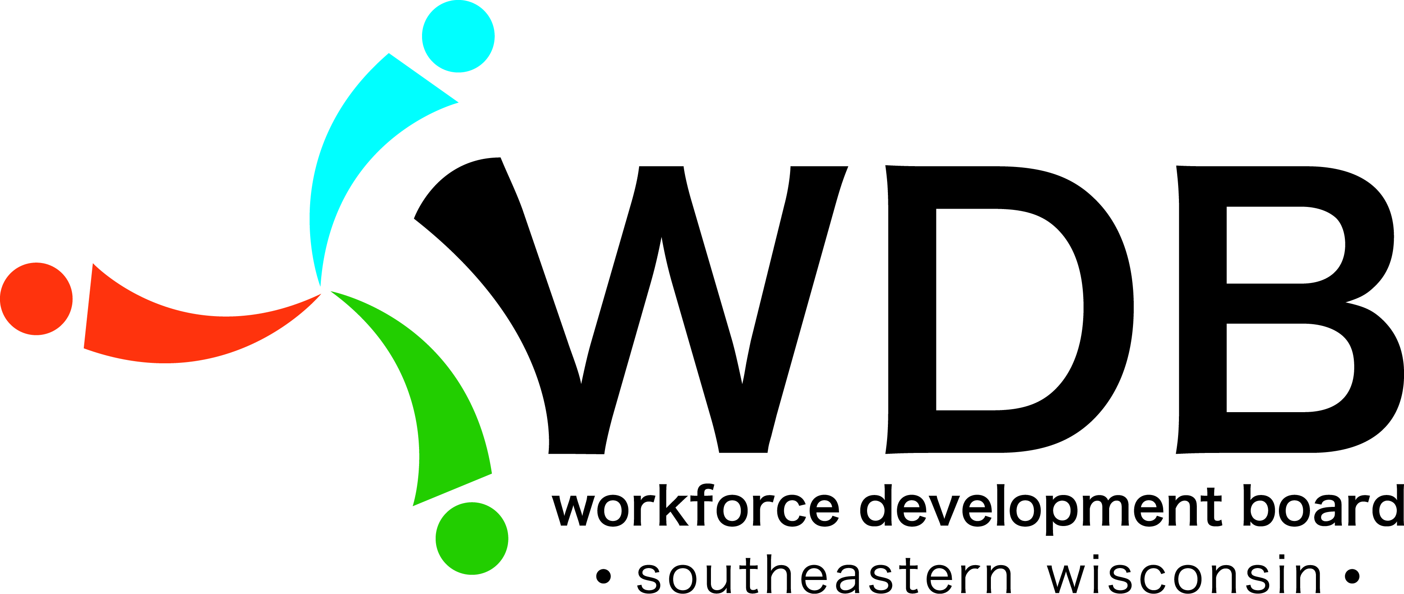
Southeastern Wisconsin Workforce
Development Board
Agenda

Date: Tuesday, May 14, 2019 Location: Kenosha County Job Center
8600 Sheridan Road ~ Kenosha, WI

Time: 9:00 a.m. to 11:00 a.m. Room: Conference Room North 2

Agenda items:

Item # | Topic
 | Call to Order
 | Silent Roll Call
 | Citizen’s Comments
 | Approval of February 19, 2019 Meeting Minutes - A
 | Board Update
 | Fiscal Report – A
 | Allocation Update
 | ETP (Eligible Training Providers) Approvals - A
RFP Discussion (closed session) - A
There may be a vote to go into closed session pursuant to sec. 19.85 (1)(e), Wis. Stats., for purposes of deliberating investing of public funds or conducting other public business where competitive reasons require a closed session, specifically the discussion of RFP proposals, the evaluation of the same, and determining which to select. Should the Board go into closed session, they will return to open session immediately upon completing this item.
RFP Recommendation Vote – A
- Program awards will not be publicly announced at this meeting. Notification will be made by certified mail.
 | Other Items as Allowed by Law
 | Board Chair Comments
 | Elected Official Comments
 | Next meeting: Tuesday, August 27, 2019 in Conference Room North 2 at the Kenosha County Job Center from 9:00 a.m. to 11:00 a.m.
 | Adjournment

A = Action Items

