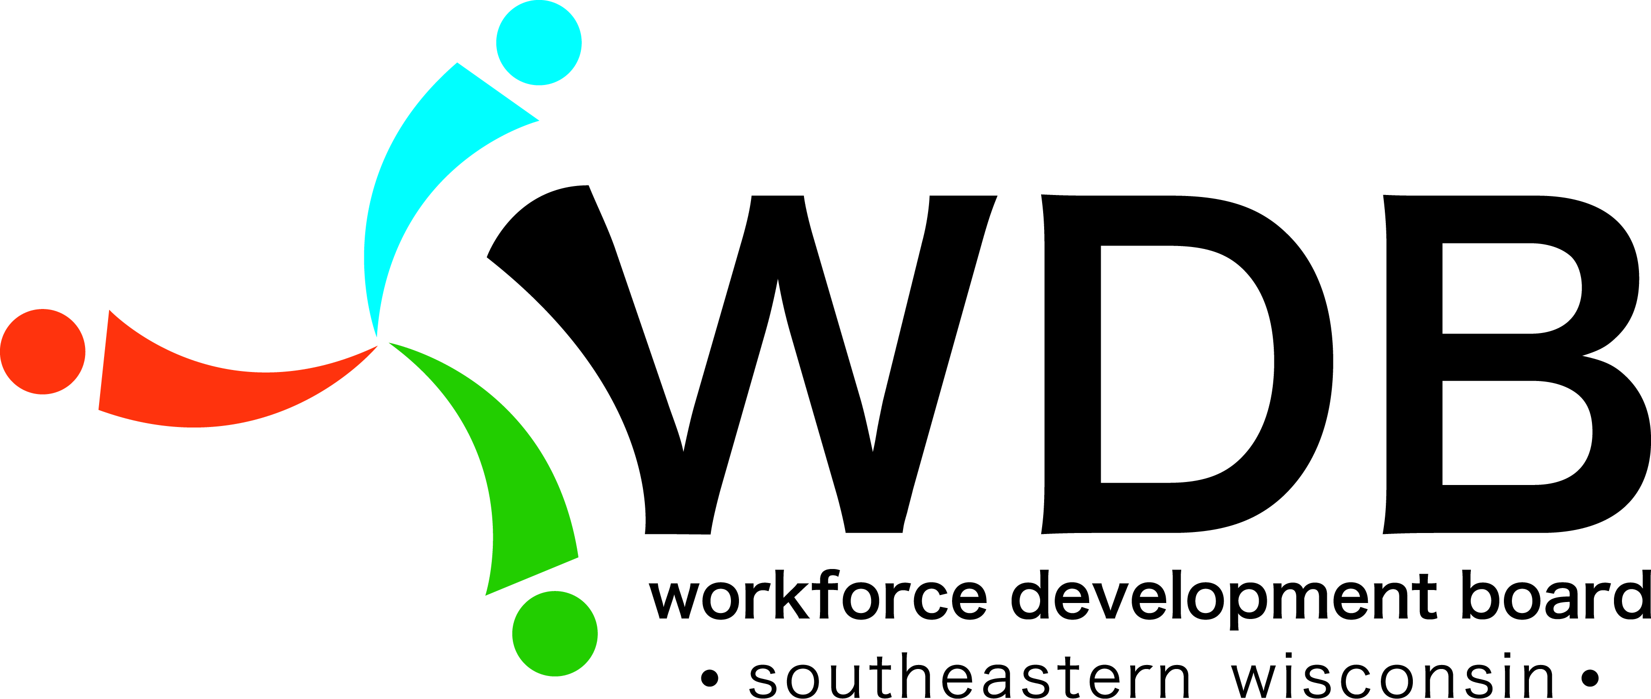
Southeastern Wisconsin Workforce Development Board Meeting
Tuesday, November 19, 2019
Kenosha County Job Center – North 3
9:00 a.m. to 11:00 a.m.

Members present: Matt Janisin (designee for Dr. Bryan Albrecht), Laura Cesar, Susan Chandek, Ken Fellman, Ron Frederick, Nicholas Galich, Alexa Haigh, Brooke Infusino, Cheryl Kothe, Amy Mlot, Loretta Olsen, Lanetta Virgil, Matt Waltz
Members excused: Derek D’Auria, Dave Gaspar, Susan Hall, Paul Moeller, Tom Reiherzer, Dave Riley, Cynthia Simonsen
Others present: Doug Bartz, Michelle Blanchard, Rebecca Freund, Jacquetta Gilman, Lynn Hardginski, Chris Isaacson, Kathy Karshna, Terri Liesten, Marilyn Putz, Karen Sotak, Nina Taylor, Tom Walsh
Citizen: Diane Kastelic

Call to Order:
- Board Chair, Nicholas Galich, called the meeting to order at 9:04 a.m.

Silent Roll Call:
- Rebecca Freund completed silent roll call.

Citizen Comments:
- Diane Kastelic said she is a retired librarian and works with the local extension office. She just wanted to say thank you to the Board for the support that was given to the re-entry project that was held at Gateway. It was a great success for the service providers and was a great help to those trying to get back to work. She encourages the Board to continue their support and provide program dollars to target that population.

Approval of Minutes of August 27, 2019 Board meeting:
- Ron Frederick made a motion to accept the August 27, 2019 Board meeting minutes as written. Amy Mlot seconded that motion.
- Motion passed unanimously.

Fiscal Report (handout) – Presentation by Jacquetta Gilman, Kenosha County Fiscal:
- Jacquetta explained that there are 3 new columns on the spreadsheet – 1) approximate monthly spending; 2) when Fiscal expects to expend all those dollars; and 3) Fiscal notes / Program description.
- Jacquetta gave an in-depth overview of the Fiscal Report.
Windows to Work (WTW) Update – Doug Bartz:
  - Doug said that he has been in discussions with the Department of Corrections to expand services into Racine Youth Offender Correctional Center (RYOCC).
  - A Windows to Work Coach will be stationed at that Center to provide services up to 6 months prior to their release date to assist with employment, training needs, supportive services and we follow them for up to one year after they’ve been released.
  - Doug said that discussions are being held to open two job centers in the coming year - - - one in Racine Correctional Institution (RCI) and RYOCC.
Ron Frederick asked about the Coach position and Doug explained that the grant is ran out of Racine County Human Services. Ron Frederick commented that he’s happy to hear this because the correction population receives very little assistance right now.
Brooke Infusino commented that she’s heard about the expansion and how it’s working great in other areas around the State and she’s happy to hear that they are looking to expand here.

- Brooke Infusino made a motion to accept the Fiscal report with Amy Mlot seconding that motion.
- Motion passed unanimously.

WIOA Overview (handout) – Doug Bartz:
- Doug stated that the direction we have been given is to give the Board a breakdown of what WIOA is. This month an overview will be given and then we’ll get into the functions of the Board and then into programming.
- Doug explained that funding comes from the Department of Labor down to the State and they have allocations to the Workforce Development Boards.
- Dynamic Workforce Solutions (DWFS) is our service provider for Title I – Adult, Dislocated Worker, Youth, and Business Solutions.
- Doug mentioned that people come into the Job Center, it’s not just about WIOA, it’s about connecting that person to the services that they need whether it be DVR, FoodShare, Veteran services, Badgercare………….. there are so many different opportunities throughout all of our buildings.

Amy Mlot said that she has worked with all three of the Job Centers and the traffic seems to be higher in Racine. Doug said that there is definitely more traffic in Racine due to unemployment rate and population.

One-Stop Operator (OSO) Report (handout) – Michelle Blanchard:
- Michelle said thank you to Doug, Rebecca, and Marilyn for all of their support, guidance and expertise during the transition and implantation of the contract. It has been a pleasure working with Board staff and also meeting with many of the Board members directly to get input and advice.
- Michelle discussed the comparison of Resource Room traffic from last year to this year; it has remained about the same even with unemployment going up and down.
- First partner meeting was held in September and meetings will be held quarterly. Some of the key takeaways from this meeting were the goals of the partners and what they would like to get from each meeting.

WIOA Program Report (Business Solutions) – Michelle Blanchard & Kathy Karshna:
- Michelle said that 79 outreach events have been attended over the past 100 days and they’ve held 13 information sessions with over 370 attendees.
- Michelle said that there is a Quality, Performance, and Training staff member to monitor cases on a monthly basis. DWFS strives for less than 5% error rate - - there was bit of a transition but the error rate has come down as of October.

Matt Waltz asked for an example of those errors. Michelle said that it could be something such as a timely monthly contact; policy states that we need to have contact each month.
Matt Waltz asked how many participants have completed training, earned their credential and have gained employment. Michelle said that training is more longer term – 1 year to 2 year degrees right now but they are looking into the short term training options. CDL training is short term and those participants are getting employed right after they complete.

- Kathy Karshna introduced herself and gave a brief overview of Business Solutions and explained what type of services that they provide:
  - Talent Acquisition – recruiting new employees
  - Rapid Response – lay off/closure assistance to make employees aware of services available
- 107 on-site recruitments for the 1st quarter of the contract (July, August, and September) with 770 attendees.
- 4 Job Fairs have been held with over 700 job seekers in attendance.

Brooke Infusino asked if the on-site recruitments were a cluster of employers or individual employers. Kathy said that they were individual employers.
Brooke Infusino asked if there is any follow-up to those employers to find out how many job seekers are getting jobs and Kathy stated that they do a survey and they are highly satisfied and it’s hard to determine how many have been hired.

Labor Market Information – Presentation by Tom Walsh, DWD – Labor Market Economist:
- Tom Walsh said that the Region has followed the State with the unemployment rate.
- 60% of the jobs within the Region are automated; meaning technology friendly.
- Tom went over the industry and occupation projections.

WDB Executive Committee Report – Board Chair, Nicholas Galich:
- Board Chair, Nicholas Galich said that last year we made a change to the Board structure.
- The Committee is reviewing the way that data is shared with the Board and making changes so that it’s presented in a more meaningful way.
- With many new Board members and those have been on a for a while, it’s important for people to get a sense of the information and what we are presented with so that everyone stays refreshed on the functions.
- If you have any questions, please feel free to connect with Nicholas.

Other Items as Allowed by Law:
- The State did their Monitoring the first week of November and the results of that will be shared at the next meeting.

Board Chair Comments:
- Nicholas Galich commends Michelle and her team, as the Board Chair and as an employer, because they’ve done an outstanding job in our community. It’s refreshing to have a great response and we are grateful.
- Nicholas thanks Doug, Rebecca and Marilyn for their work during the transition and the significant changes to get the Board to the next level.
- The Board is here to provide oversight and insight so if you have anything to share, please feel free to connect with Doug and/or Michelle.
- There is a new Facebook page and Nicholas encourages all to like the page. Amy Mlot asked to confirm which page it is - - SE Wisconsin Employment Central and Michelle said that’s the page.
- Nicholas appreciates everyone’s attendance at these meetings; please respond to Rebecca immediately about attending meetings. It is important to determine whether or not we have a quorum so that we can proceed or cancel the meeting.
- Board Chair Nicholas Galich wishes everyone a great holiday season and we’ll see you all next year.

Local Elected Official Comments:
- No comments.

Next meeting:
- The next meeting will be held on Tuesday, February 4, 2020 at the Kenosha County Center from 9:00 a.m. to 11:00 a.m. in Conference Room North 2.

Adjournment:
- Ron Frederick made a motion to adjourn the meeting with Matt Waltz seconding.
- Meeting adjourned at 10:21 a.m.

